Higher education in the Republic of Kazakhstan and the Bologna process
Mukhametkalieva G.O.
Kainar university
Kazakhstan

The Republic of Kazakhstan has successfully implemented the best recognized and most widely spread in the world model of specialists’ training through three-level structure:
Bachelor,Master, PhD.
Now methodic and systematic work to improve the content of educational programs is carried out for each of the three levels.

The credit technology
The credit technology of education has been introduced to ensure the international recognition of the national education programs, to provide students and faculty with academic mobility opportunities, as well as to improve the quality of education.
Devotion of our universities to the commonly accepted principles of university education was proved by the fact of their signing the Magna Charta Universitatum. 18 universities from Kazakhstan have so far become the signatories of the Magna Charta. Universities of Kazakhstan have become really involved into this process since it gets us closer to the Bologna Declaration.

The rapprochement of Kazakhstan higher education to Bologna process.
Currently, Kazakhstan is focused, coherent work on the rapprochement of Kazakhstan higher education with the educational systems of member countries the Bologna process.
Each year, increasing public spending on education. For example, in 2008 expenditure on education increased by 2.8 times compared with 2004 and amounted to 4.7 billion dollars (558.5 billion tenge). Their share in total GDP is 3.7%. This corresponds to the level of countries such as Germany, Slovakia, Spain.

Expenditure on education

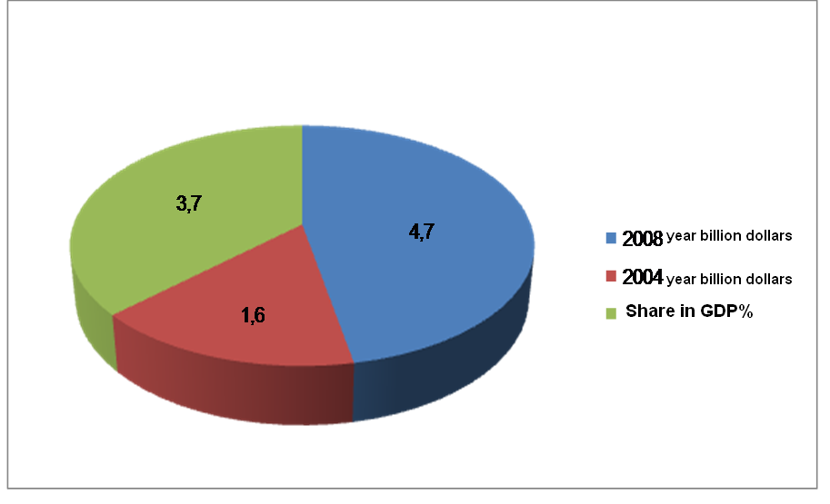
- In 2008, education was allocated approximately 4.7 billion dollars (558.5 billion).

The total number of students
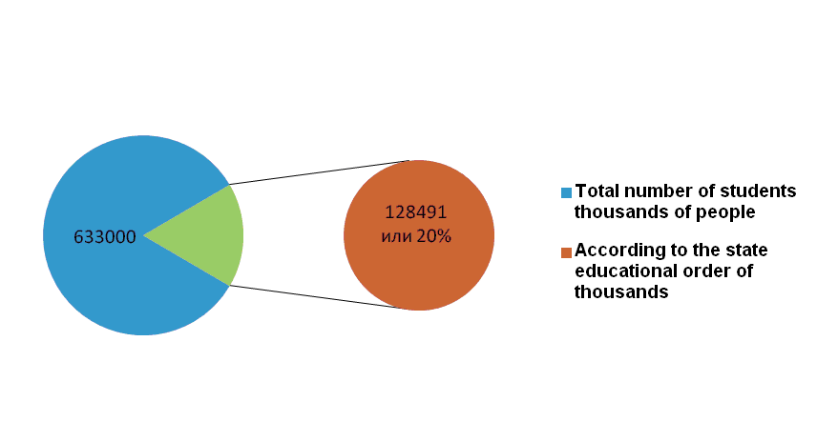
The total number of students in higher education is more than 633 thousand people, of them by the state educational order are trained 128,491 people, or 20% of the total number of students.
Number of students per 10 thousand population is 512 people.

The number of teaching staff in universities

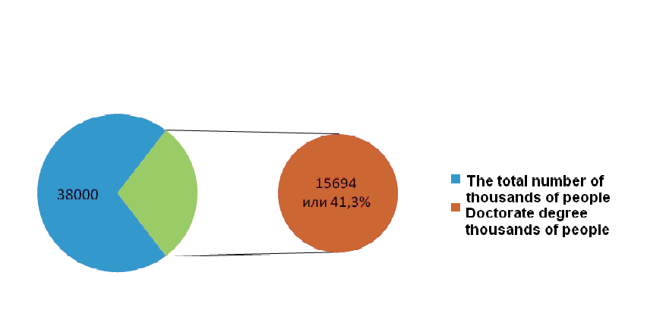
- The number of teaching staff in universities is about 38 thousand people., Of which 41.3% have a doctorate degree and Ph.D.

The autonomy in decision-making in the educational process

In accordance with current legislation in the field of higher education institutions in Kazakhstan have a right to self-government, autonomy in decision-making in the educational process organization, staffing and implementation of financial and economic activity.
Universities provide a wide range of educational services, to establish direct relations with domestic and foreign partners, enter into contracts on cooperation in the field of training and retraining of personnel, training and exchange of experiences of teachers, students and masters.

International standards at the Kainar University

The introduction of the Bologna Declaration and is happening at the University of Kainar. Training programs are provided in conformity with international standards, a continuity of educational programs at various levels of education, educational programs adapted to the labor market, etc.
Admission to the school on the basis of a single national testing and integrated testing. According to the results of national testing of applicants on a competitive basis, are awarded educational grants.
Applicants that have overcome the established threshold, but did not receive educational grants may enroll in university on a fee basis of payment.

Double-diplomas' project

Ever since 2007 we have been aimed at implementing the programs of double-degree or two-diploma education. For these purposes the Ministry has organized and held quite a number of meetings and forums.
On September 10, 2008 a meeting of representatives from foreign and Kazakhstani universities was held on the basis of the Eurasian National University named after Gumilev. It was aimed at the practical realization of the two-diploma project. This forum welcomed 27 universities from Great Britain, Ireland, Spain and the USA as well as 31 universities from Kazakhstan. Opinions exchange concerning the issues of higher education took place within this forum, including those connected with implementation of two-diploma education. The results of the meeting speak to themselves: there were signed 38 Cooperation Memorandums between 12 foreign and 29 home universities.

Realization of state policy

Higher education modernization became one of the most important conditions of State system development and consolidation of independence in the sphere of economic and policy. In order to get it legislative basis, system of managing and financing were reformed. These actions promoted Kazakhstan to integrate in international space. Realization of state policy in the sphere of education is to provide in the following currents: improving training of the staff; development of new educational techniques; perfection of students contingent forming model; improving of students academic mobility; development of fundamental science and promotion of institute’s of higher education role as a scientific-research centers; improving of effectiveness of economical and financial institute’s of higher education work; modernization of institute’s of higher education system managing.

Organizational structure of institutes

Modern system of higher education in Kazakhstan contains 140 institutes of higher education. These are 81 universities, 32 institutes, 26 academies, a conservatoire. All of these institutes prepare stuff for various currents. 9 of them has national status.
Organizational structure of institutes of higher education consists of departments and chairs where professors, docents and assistants realize their scientific-pedagogical work. Teaching staff is formed from among doctors, candidates and masters of Science owning to competitive choice and inner attestation.
National system of higher education is multi-stage and includes Bachelor, Master and PH.D levels. Every year more than 700 000 Bachelors, 3000 Masters and 100 PhD study in the Kazakhstan institutes of higher education.

Integrative processes in higher education

Kazakhstan entry into the world educational and science area is one of the most important trends of Kazakhstan politics and the development of external politics of the country. The participation in this process means the increasing in competitiveness of Kazakh educational services and recognition of adequate services in world standards.
The Convention of “The recognition of qualifications that is related to the European higher education” is the basic document of strategy of process. It was promulgated in Lisbon in April 1997 by UNESCO. December 1997 Kazakhstan together with 42 countries signed and ratified the Convention. Due to it Kazakhstan became a participant of international projects, programs and agreements such as “The European Convention of the equivalence of diplomas that have an access to universities” (1953), qualifications” (1959), “The European Convention of the common equivalence of the periods of university education” (1990) etc.

KAINAR University

The KAINAR University cooperates with 15 Institusions of Higher Education in the far and near foreign countries.
The main partners are: MGIMO(Russia),The University of Reading (Great Britain),University of Brighton(United Kingdom), Universite Paris XII- val de Marne(France),Institute CEDIMES(France),University Rijeca(Crotia), University “Valahia” Targoviste(Romania),Istambul University(Turkey) etc.
In 1995 the Kainar university gained the grant of the Tempus –Tasis project-
№ 02401,in 1998-grant of the UNESCO, grant of the “Eurasia” fund and in 2001-2004 grant of the USIS.The Kainar University alumni have the possibility to enter the Master`s degree courses and post graduate ones in the MGIMO and University of Reading (Great Britain), University Paris-XII val-De-Marne.
In 2000 the Kainar University became the member of the International Association of University has been UNESCO. Since 2002 the Kainar University has been the member of CEDIMES economists-francophone Association.

Education in Kazakhstan

Kazakh higher education system closer to the education systems of countries of Bologna process.
Today about 19 thousand Kazakh people study in more than 35 countries of the world. 16.4 thousand people study in Russian institutions of higher education. Every year the geographical cooperation in the sphere of education and science expands.
Education of Kazakh people abroad realizes according to the following trends: international educational exchange programs; grants of the foreign countries governments and international organizations; private education; international grant of “Bolashak”.

Integration processes

The cooperation of the European Union programs “TASIS” and “TEMPUS” is rather successful. These programs are intended for setting academic connections between universities of Kazakhstan and countries of the European Union.
Integration processes that are observed in national and world economy make the quality of education dominated in the competitiveness supplying of higher education institutions. Therefore Kazakhstan needs not only highly professional people but also the best-quality universities that are highly educational research and scientific productive complexes.

High schools of Kazakhstan

In the high schools of Kazakhstan widely practices such form of the international cooperation, as lecturing by leading professors of high-educated high schools of near and far abroad. Students, Master of PHD and teachers have possibility to attend lecture of professors and teachers of University Exeter, the Oxford University, School of the right of Royal London College (England), Ejdhovensky university, Tvente University (Netherlands), the Washington university, the Harvard university, University of Arizona, University of Colorado, Pittsburgsky University, National Institute of Health (USA), the Russian

International cooperation

University of friendship of the people (Russia), the Moscow state university of M.V.Lomonosov (Russia), the Western-Australian University (Australia), Institute of political researches of the Russian Academy of Sciences (Russia), etc. Along with it the Kazakhstan scientists are invited for reading of specialized courses in recognized foreign high schools, for an exchange of scientific achievements get the inventions of applied character patented by conducting domestic experts in various areas of a modern science and techniques.
The major direction of expansion of the international cooperation the international cooperation for domestic high schools is the conclusion of contracts on long-term partnership with consortia, agencies, services, educational councils, centers of science on cultural cooperation and the academic exchange.

